

A Project Report On

***STUDENT INFORMATION SYSTEM***

By

*Tulasi Darisi*

Bacherlor of Technology

Batch: 2020-5345

Under the Guidance of

Jayanth V

Technical Trainer

EduBrdige

(School of Coding)

**Introduction:**

Our project explains about storing the data in database if any student enter there details in Registration Form present in our web page. You can see all students data in our database.

I have developed this Application in **Java, JSP, CRUD and MYSQL.** It**’s** a web-based projects so I have used **HTML** also.

The main feature of the project is to make a clear list of all the students in present in a class to find their details easier. You can access this website from anywhere and everywhere.

Using Front end Technologies we create login, logout, Registration form web pages to enter their details. Once you enter data the data is stored in database. If you want to Edit, Delete or Update user details you can do it by re-login to user Email account.

We can also give Background for every web page.

The data stored in Database present permanently using Backend Technologies.

Java and Html are used to write necessary code to create Dynamic Web Pages.

**Software Requirements:**

**Front End:** Java /J2EE technologies (JSP, CRUD), HTML**.**

**Back End: MySQL** workbench 8.0 CE.

**Middleware/Server**: Apache Tomcat v7.0.IDE: Eclipse IDE for Java EE.

**Browser:** Best result on Google Chrome.

**Operating System**: Windows 10.

***SCREEN SHOTS***

**JSP LOGIN PAGE:**

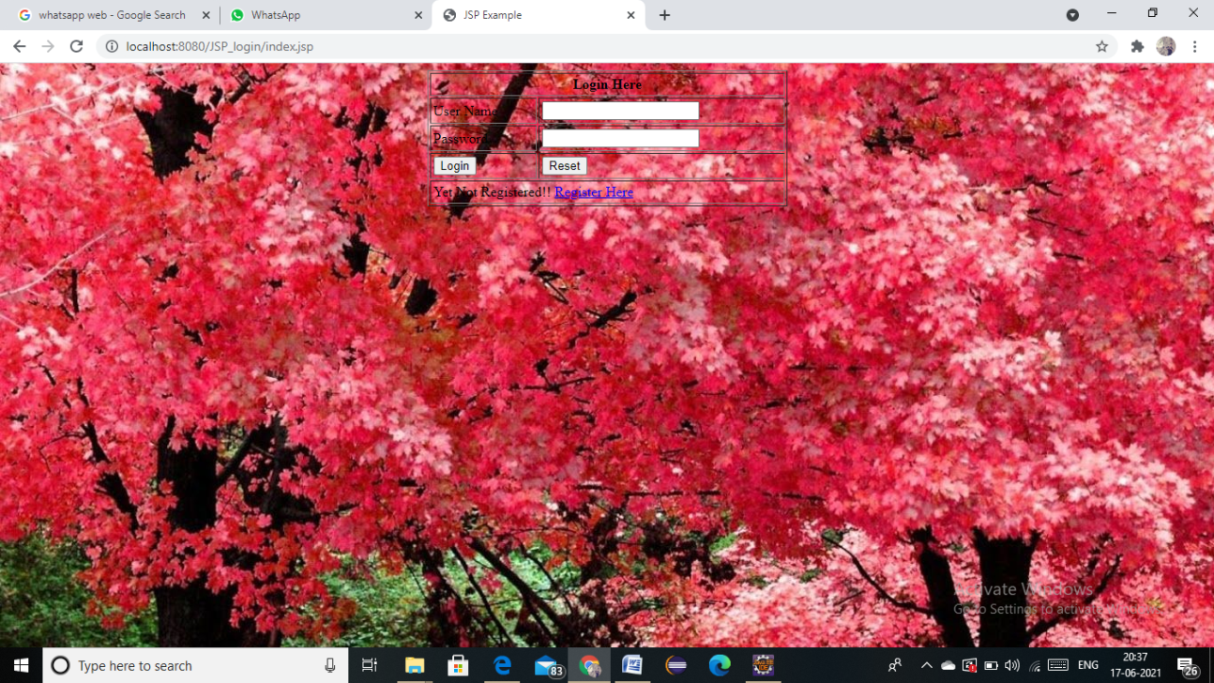

**JSP CRUD REGISTER FORM: :**

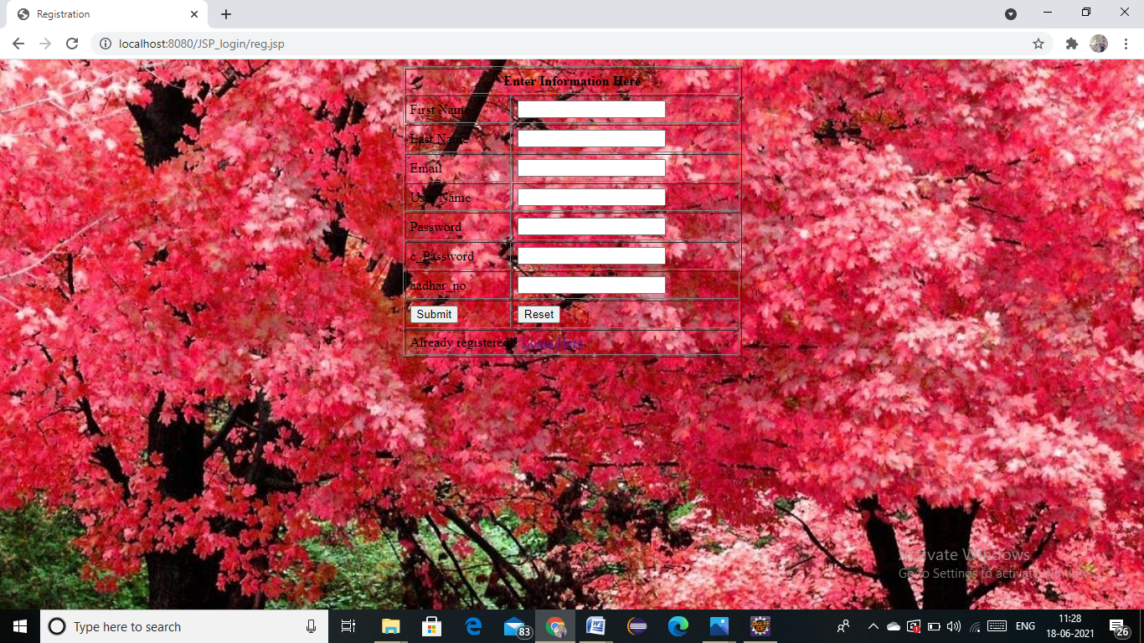

**REGISTRATION SUCCESSFUL PAGE:**

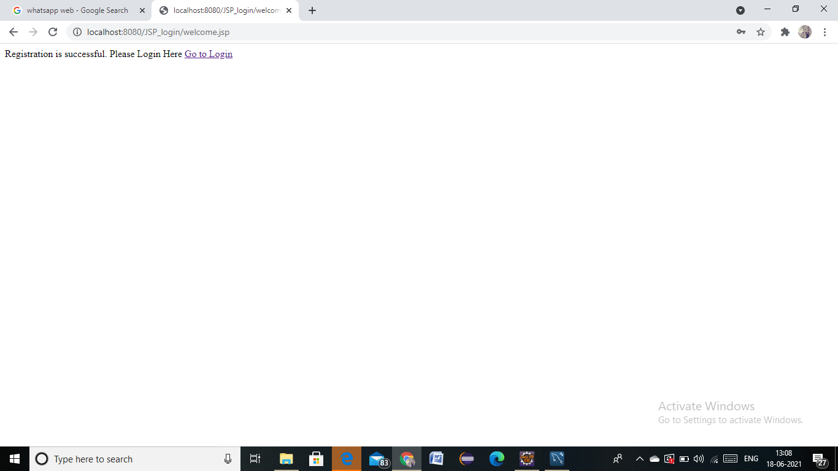

**PASSWORD INVALID PAGE:**

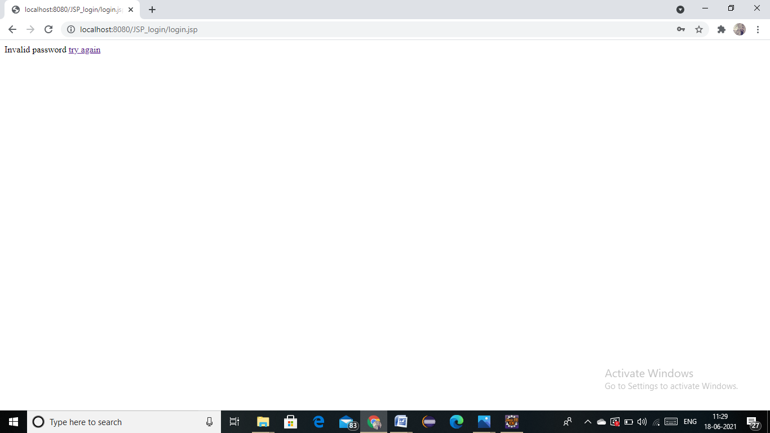

**WELCOME PAGE:**

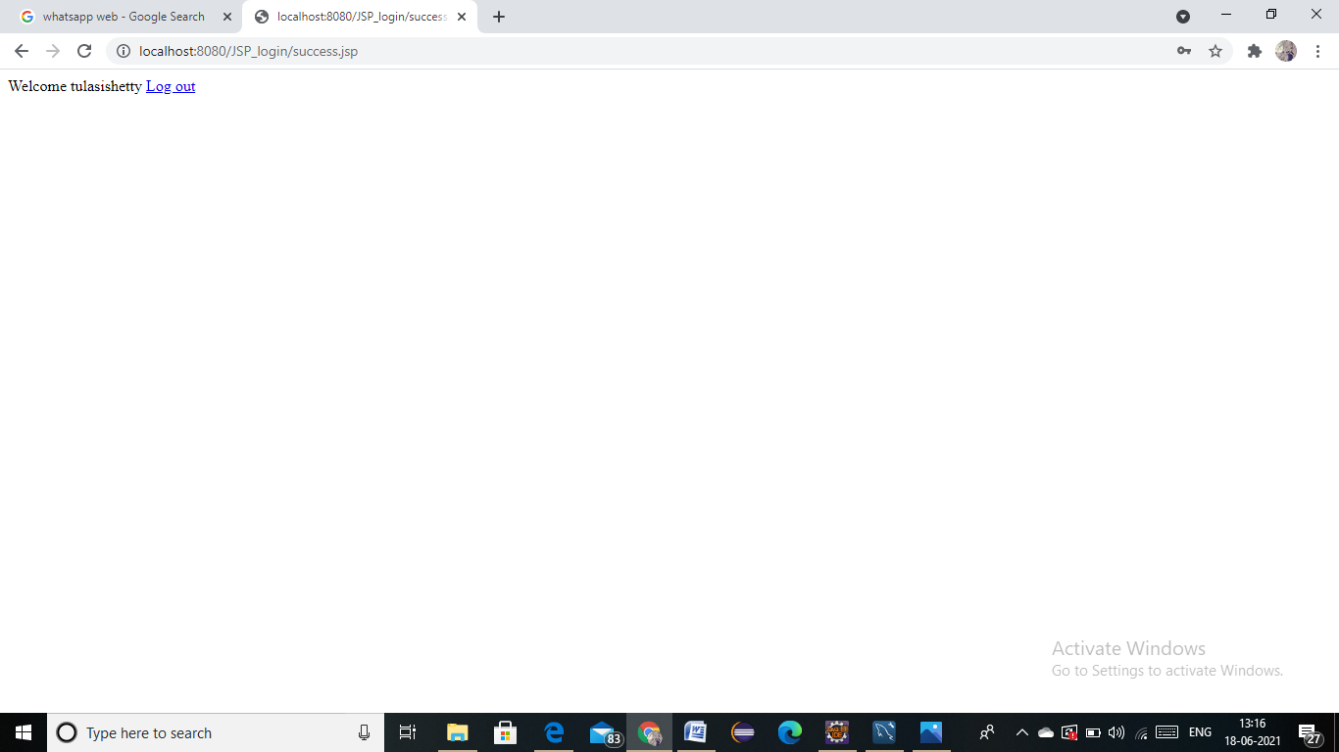

**DATA ADDED IN DATABASE SUCCESSFULLY:**

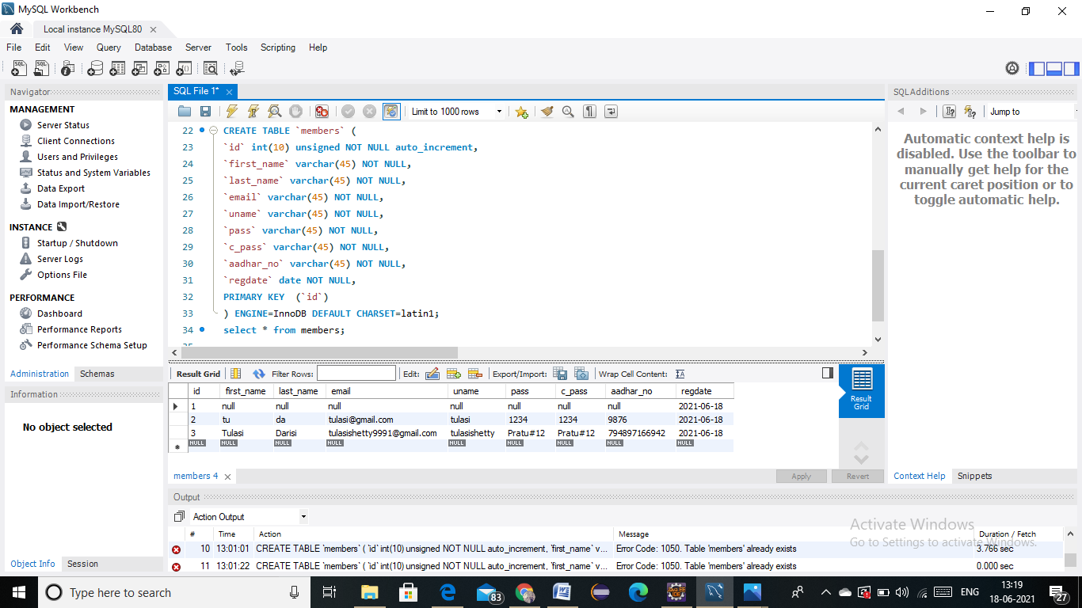

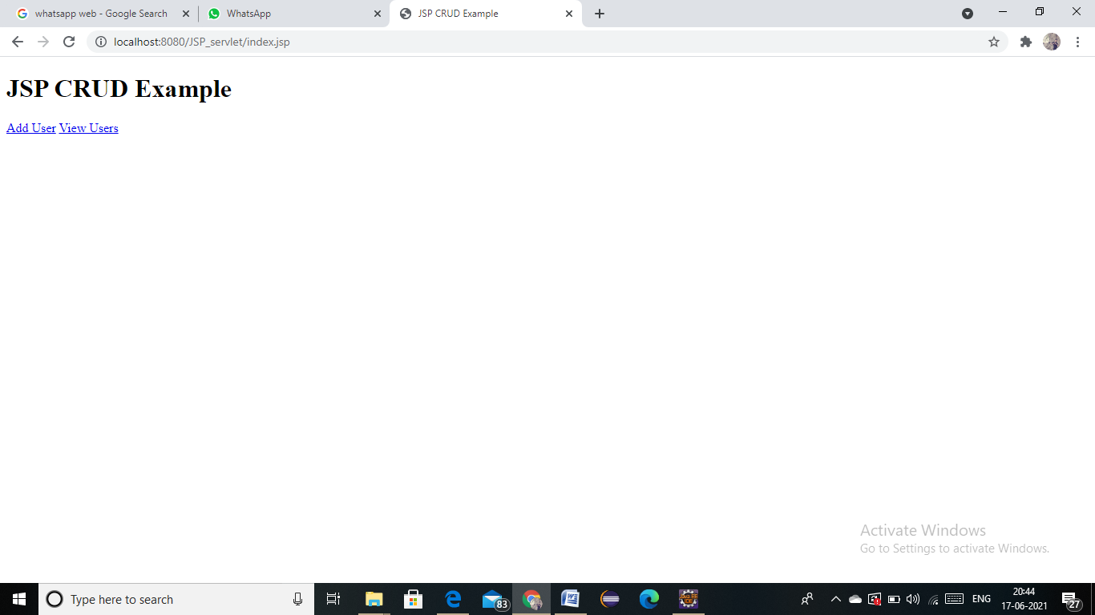

**JSP CRUD ADD NEW USER PAGE:**

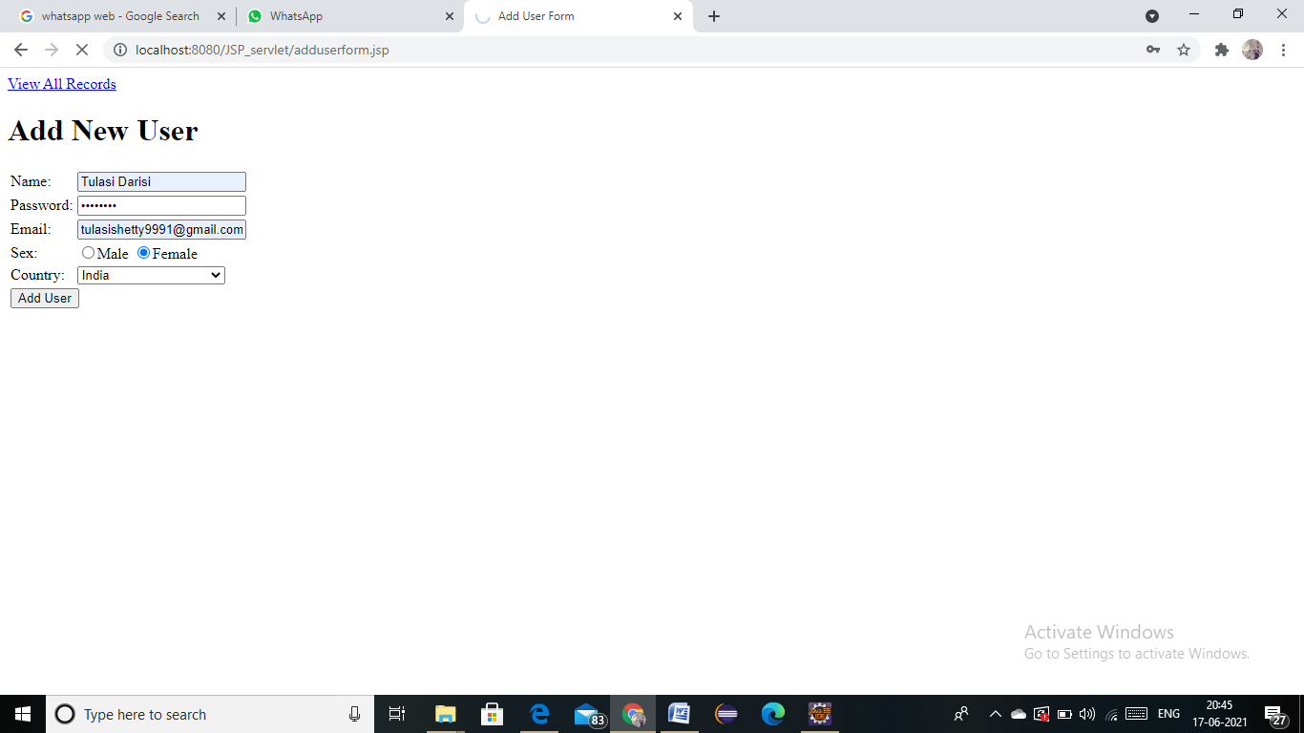

**JSP CRUD VIEW USERS LIST:**

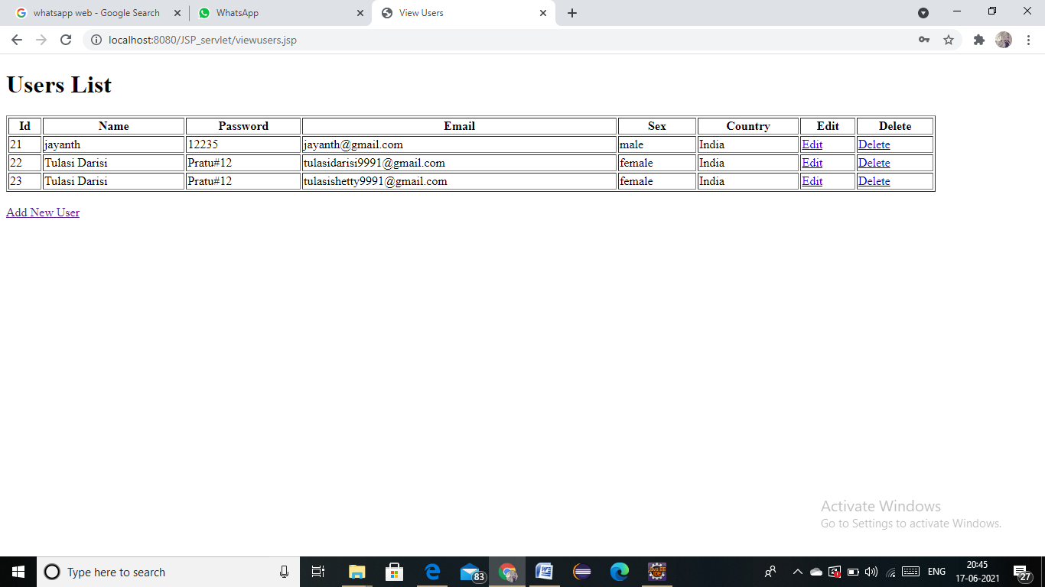

**JSP CURD EDIT FORM:**

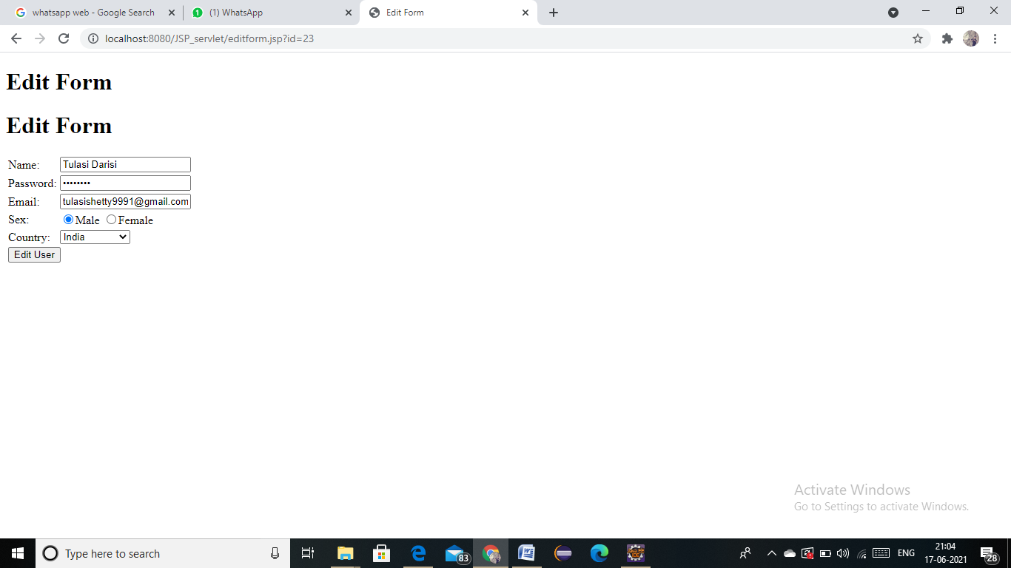

**JSP CURD USER LIST AFTER EDIT:**

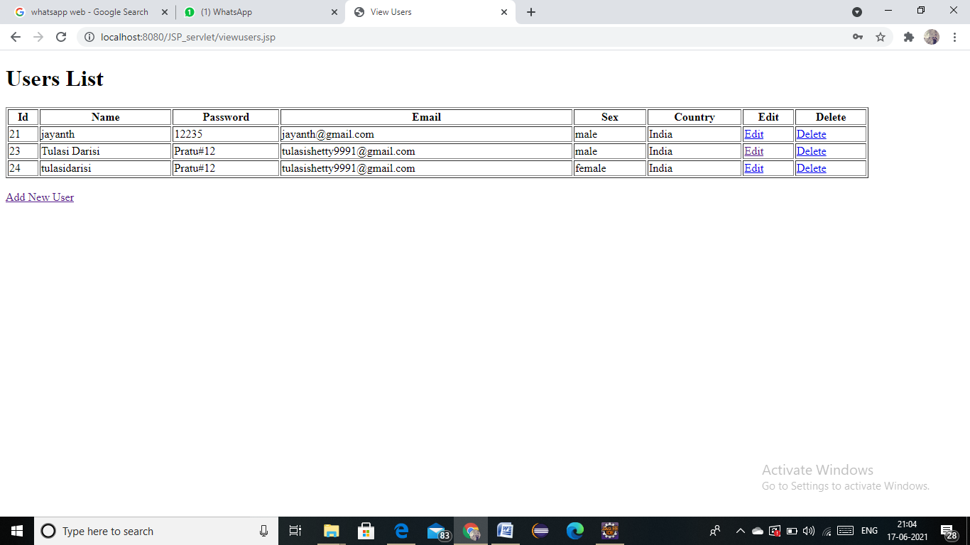

**JSP CURD USER LIST AFTER DELETE:**

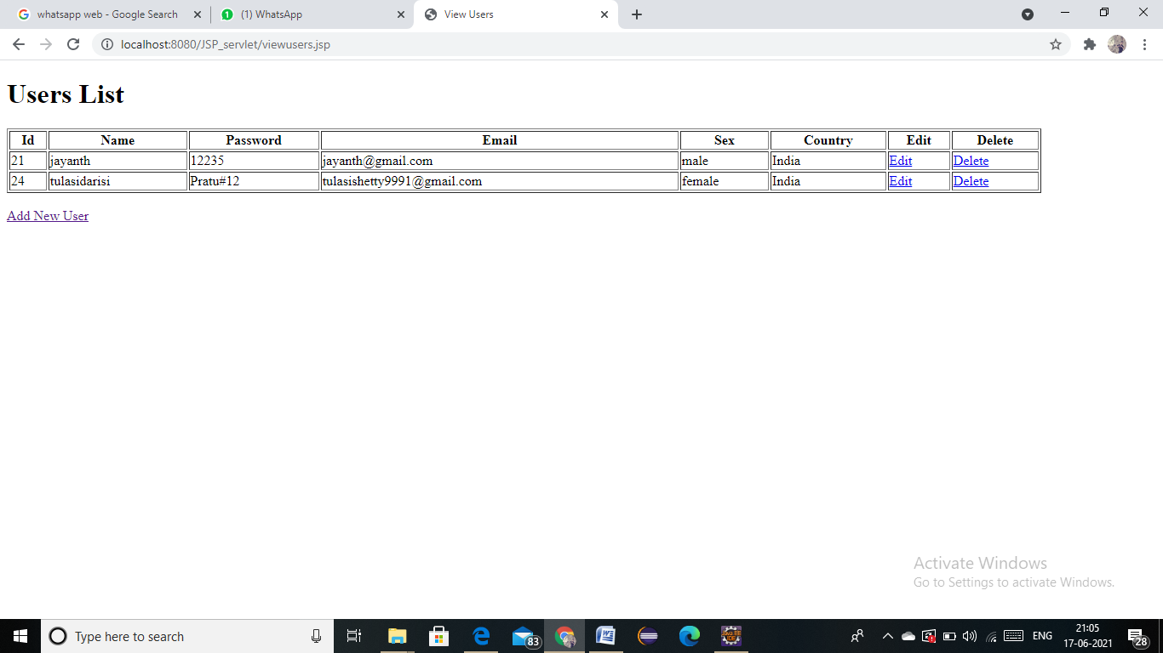**DATA ADDED IN DATABASE SUCCESSFULLY:**



